**ARDUINO LED PROJECT**

**Serial Communication(SEND)**

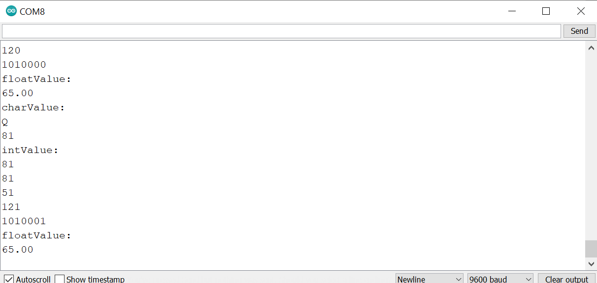

For this project we will need:

* Arduino board.

Circuit Design:

1. First make sure that the Arduino is powered off on.
2. Upload the following sketch to your arduino

|  |
| --- |
| char chrValue = 65; // these are the starting value to print  int intValue = 65;  float floatValue = 65.0;  void setup() {  Serial.begin(9600);  }  void loop(){  Serial.println(“charValue: “);  Serial.println(chrValue);  Serial.println(chrValue, DEC);  Serial.println(“intValue: “);  Serial.println(intValue);  Serial.println(intValue, DEC);  Serial.println(intValue,HEX);  Serial.println(intValue, OCT);  Serial.println(intValue, BIN);  Serial.println(“floatValue: “);  Serial.println(floatValue);  delay(1000); // delay a second between numbers  chrValue++; //to the next value  intValue++;  } |

char chrValue = 65; // these are the starting value to print

int intValue = 65;

float floatValue = 65.0;

char shows the value is expected to be a character. It can either be alphabet or a symbol or even number. It signifies a collection of such values stored as 1 value.This allows operations on the values as individual values.

int shows the value is a number. Values declared without the keyword const can be modified later in the program execution.

float this shows the value is a number with values after the decimal point

Serial.begin(9600);

This initializes communication via serial communication port. This provides the user an interface to interact with the program during execution.

Serial.println(chrValue, DEC)

The DEC refers to the type of data and how it will be formatted during output. In this case it shows, the value stored in chrValue will be shown on the serial monitor as a number. This operation is possible on char referenced value because the value stored in it can be converted into a number.

Serial.println(intValue, DEC)

Serial.println(intValue, HEX)

Serial.println(intValue,OCT)

Serial.println(intValue, BIN)

This shows the different ways in which we can store and display our numbers.

DEC-Numbers written to base 10.

HEX-Numbers written to base 15

OCT-Numbers to base 8

BIN-Numbers written to base 2

chrValue++

intValue++

This increases the value by 1 every time the program executes.The value is increased after it has been used.

void setup (){}

This initializes the arduino and assigns functionality to its pins.

This also provides required resources for monitoring.

void loop(){}

After executing the void setup() function, we enter the void loop() and this function is executed continuously and repeatedly, until you Arduino is powered off.